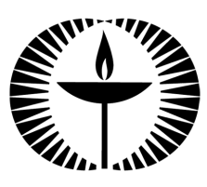
Touchstones Project
Netcards

Love Netcards with Text

Arithmetic HRJ
Art HRJ
Binoculars HRJ
Black Hole HRJ

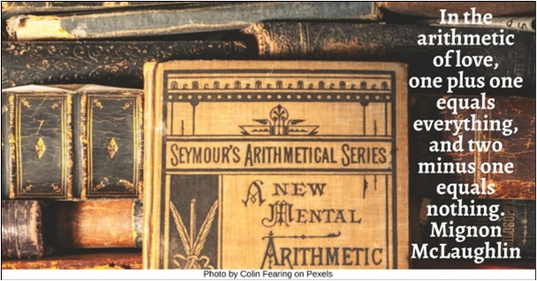

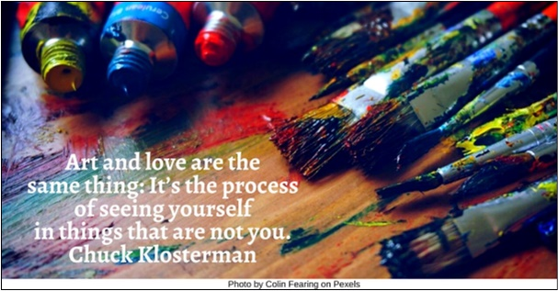

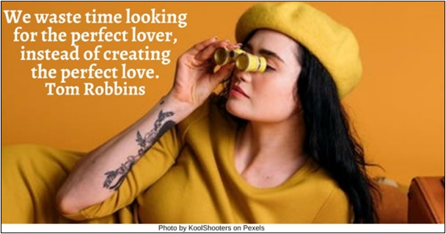

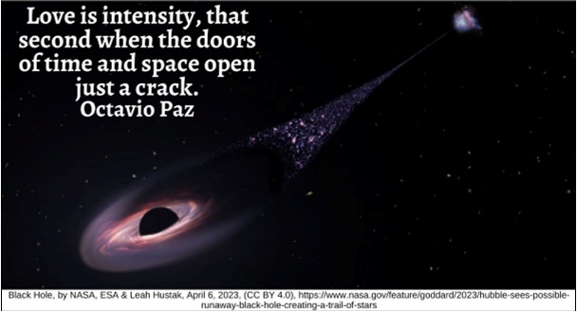

Bread HRJ
Child Helping HRJ
Dawn HRJ
Enemy HRJ

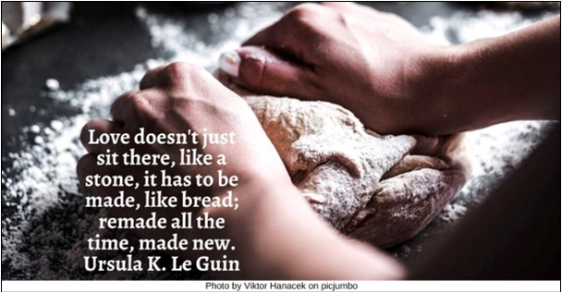

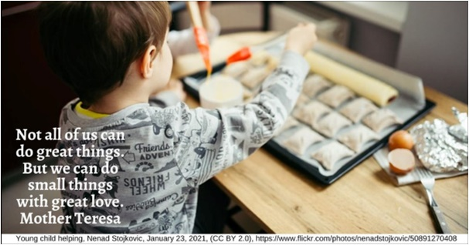

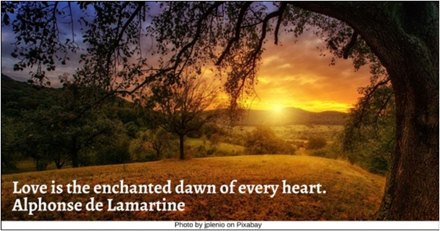

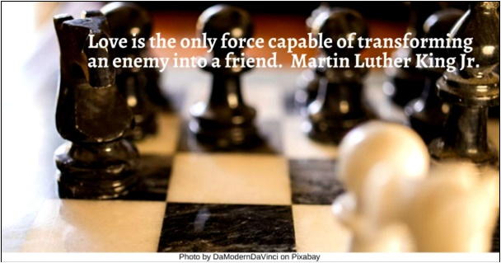

Fence HRJ
Flower Garden HRJ
Helping HRJ
Hourglass HRJ

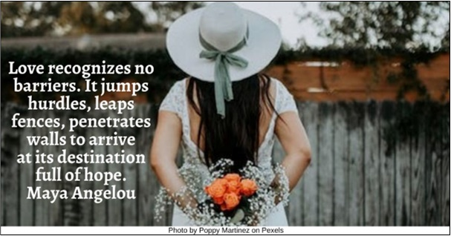

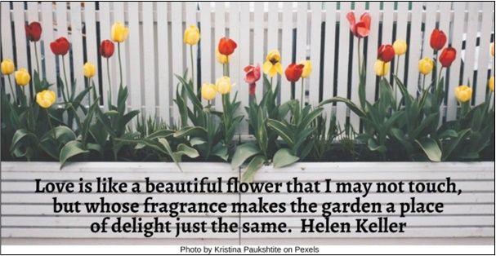

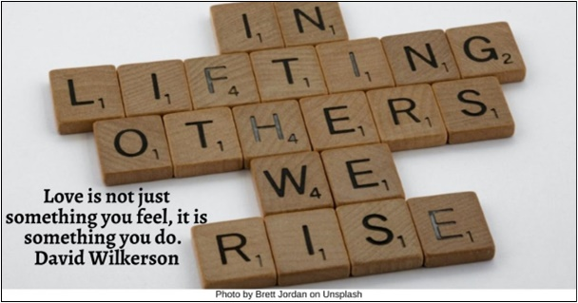

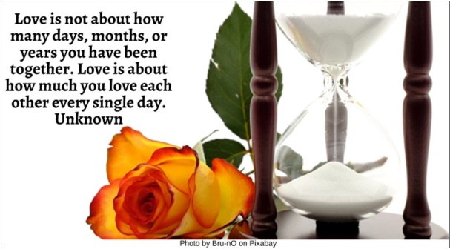

Jazz HRJ
Judgment HRJ
Key HRJ
Looking HRJ

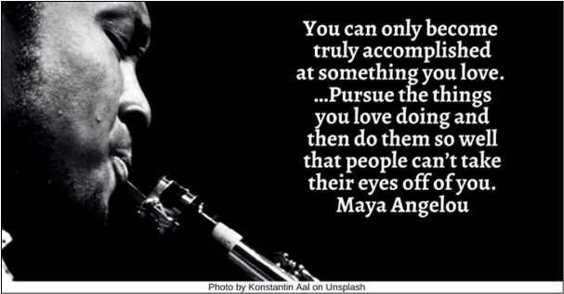

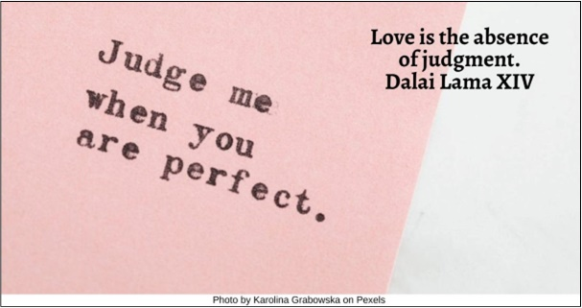

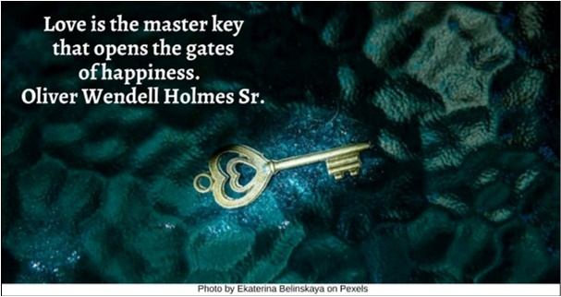

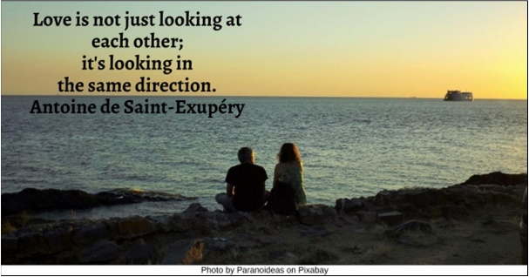

Love HRJ
Merry-Go-Round HRJ
Nighttime HRJ
No Time HRJ

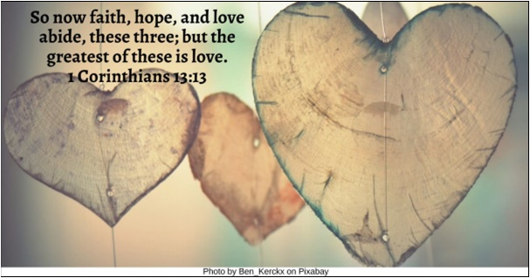

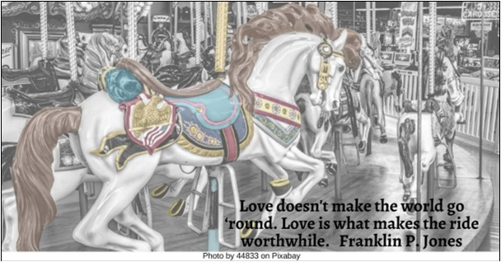

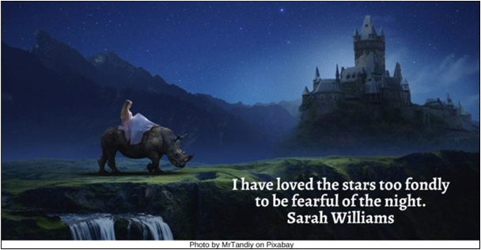

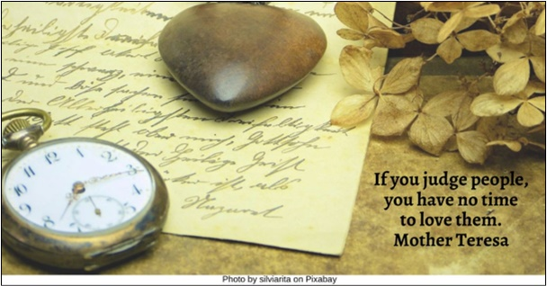

Older Couple HRJ
Painting HRJ
Protest HRJ
Seeking Justice HRJ

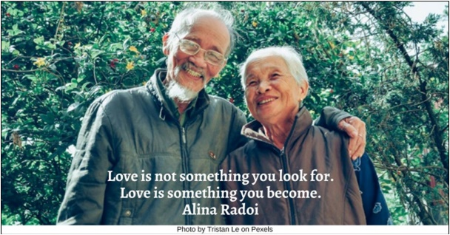

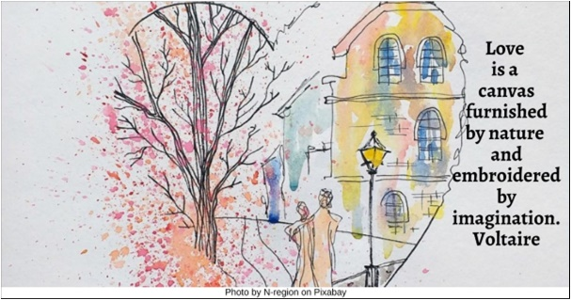

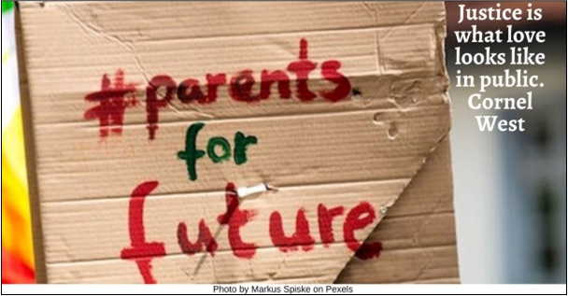

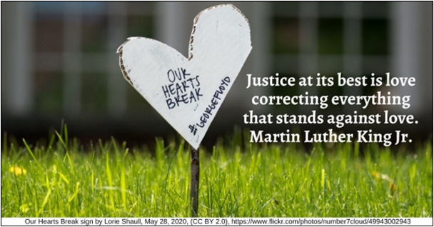

Sisyphus HRJ
Starry Night HRJ
Stars HRJ
Sun HRJ

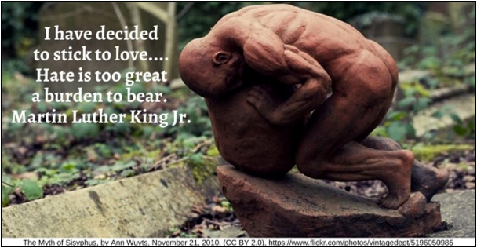

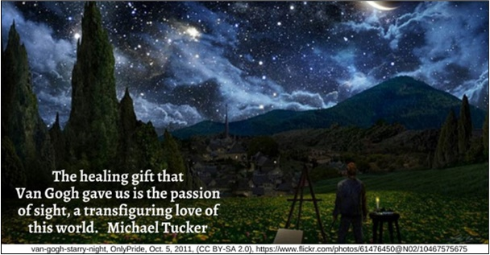

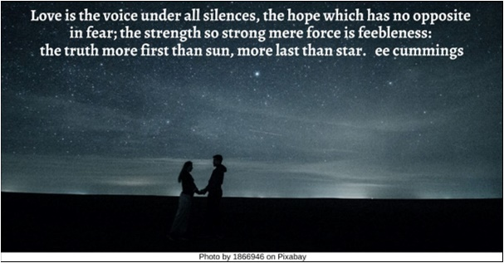

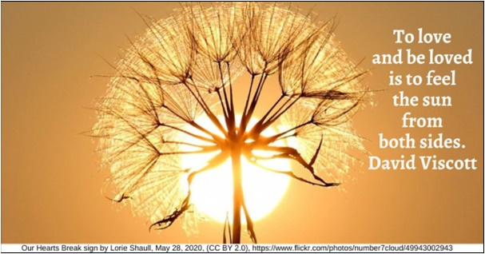

Tears HRJ
Windmill HR
Winnie the Pooh HRJ

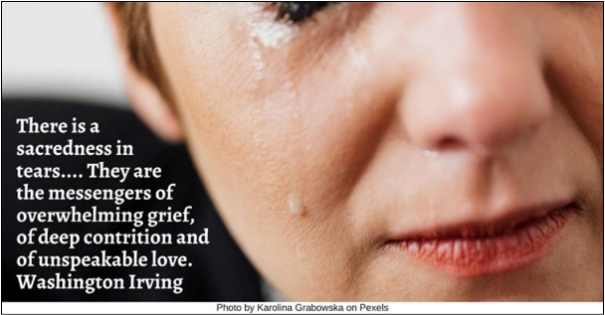

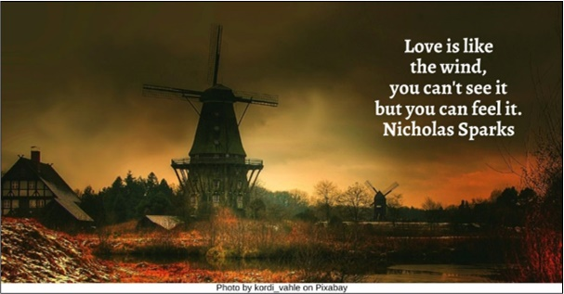

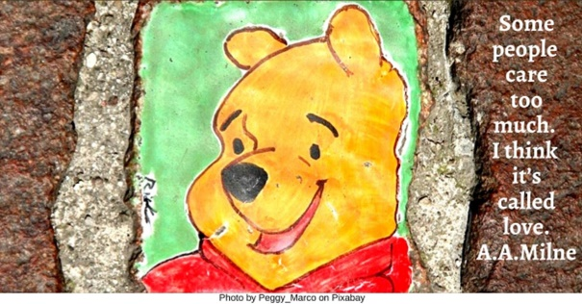

Text of Quotes
Arithmetic HRJ
In the arithmetic of love, one plus one equals everything, and two minus one equals nothing. Mignon McLaughlin

Art HRJ
Art and love are the same thing: It’s the process of seeing yourself in things that are not you. Chuck Klosterman

Binoculars HRJ
We waste time looking for the perfect lover, instead of creating the perfect love. Tom Robbins

Black Hole HRJ
Love is intensity, that second when the doors of time and space open just a crack. Octavio Paz

Bread HRJ
Love doesn't just sit there, like a stone, it has to be made, like bread; remade all the time, made new. Ursula K. Le Guin

Child Helping HRJ
Not all of us can do great things. But we can do small things with great love. Mother Teresa

Dawn HRJ
Love is the enchanted dawn of every heart. Alphonse de Lamartine

Enemy HRJ
Love is the only force capable of transforming an enemy into a friend. Martin Luther King Jr.

Fence HRJ
Love recognizes no barriers. It jumps hurdles, leaps fences, penetrates walls to arrive at its destination full of hope. Maya Angelou

Flower Garden HRJ
Love is like a beautiful flower that I may not touch, but whose fragrance makes the garden a place of delight just the same. Helen Keller

Helping HRJ
Love is not just something you feel, it is something you do. David Wilkerson

Hourglass HRJ
Love is not about how many days, months, or years you have been together. Love is about how much you love each other every single day. Unknown

Jazz HRJ
You can only become truly accomplished at something you love. …Pursue the things you love doing and then do them so well that people can’t take their eyes off of you. Maya Angelou

Judgment HRJ
Love is the absence of judgment. Dalai Lama XIV

Key HRJ
Love is the master key that opens the gates of happiness. Oliver Wendell Holmes Sr.

Looking HRJ
Love is not just looking at each other; it's looking in the same direction. Antoine de Saint-Exupéry

Love HRJ
So now faith, hope, and love abide, these three; but the greatest of these is love. 1 Corinthians 13:13

Merry-Go-Round HRJ
Love doesn't make the world go ‘round. Love is what makes the ride worthwhile. Franklin P. Jones

Nighttime HRJ
I have loved the stars too fondly to be fearful of the night. Sarah Williams

No Time HRJ
If you judge people, you have no time to love them. Mother Teresa

Older Couple HRJ
Love is not something you look for. Love is something you become. Alina Radoi

Painting HRJ
Love is a canvas furnished by nature and embroidered by imagination. Voltaire

Protest HRJ
Justice is what love looks like in public. Cornel West

Seeking Justice HRJ
Justice at its best is love correcting everything that stands against love. Martin Luther King Jr.

Sisyphus HRJ
I have decided to stick to love.... Hate is too great a burden to bear. Martin Luther King Jr.

Starry Night HRJ
The healing gift that Van Gogh gave us is the passion of sight, a transfiguring love of this world. Michael Tucker

Stars HRJ
Love is the voice under all silences, the hope which has no opposite in fear; the strength so strong mere force is feebleness: the truth more first than sun, more last than star. ee cummings

Sun HRJ
To love and be loved is to feel the sun from both sides. David Viscott

Tears HRJ
There is a sacredness in tears.... They are the messengers of overwhelming grief, of deep contrition and of unspeakable love. Washington Irving

Windmill HRJ
Love is like the wind, you can't see it but you can feel it. Nicholas Sparks

Winnie the Pooh HRJ
Some people care too much. I think it’s called love. A.A. Milne

